**MATHEMATICS SPECIALIST 3 & 4** Name_________________

**Test 1 2017**

**Section One: Calculator-free**

Reading Time: 2 minutes

Time Allowed: 21 minutes Total Marks: 21

1. (3 marks)

Sketch the graph of  on the axes below.

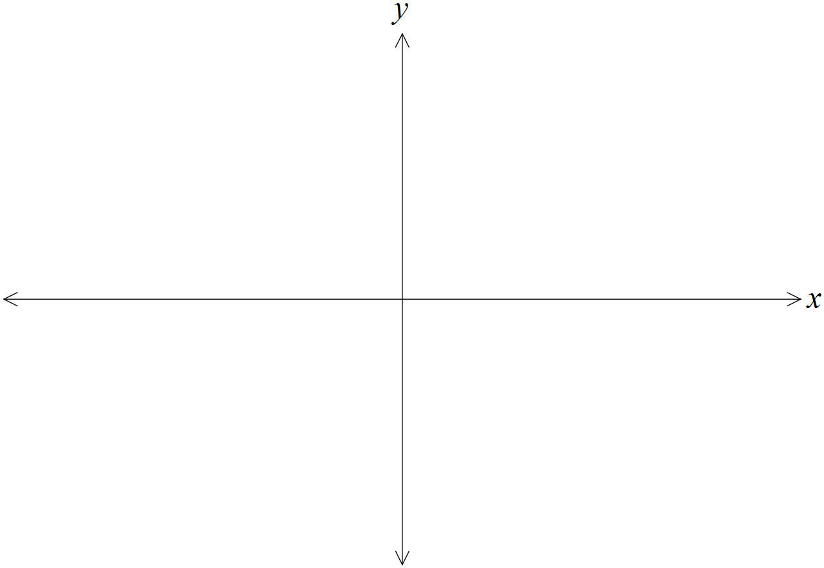

2. (5 marks)

(a) Solve the equation . (3)

(b) Solve the inequality . (2)

3. (5 marks)

Given the sketch of the function  sketch

(a)  (2)

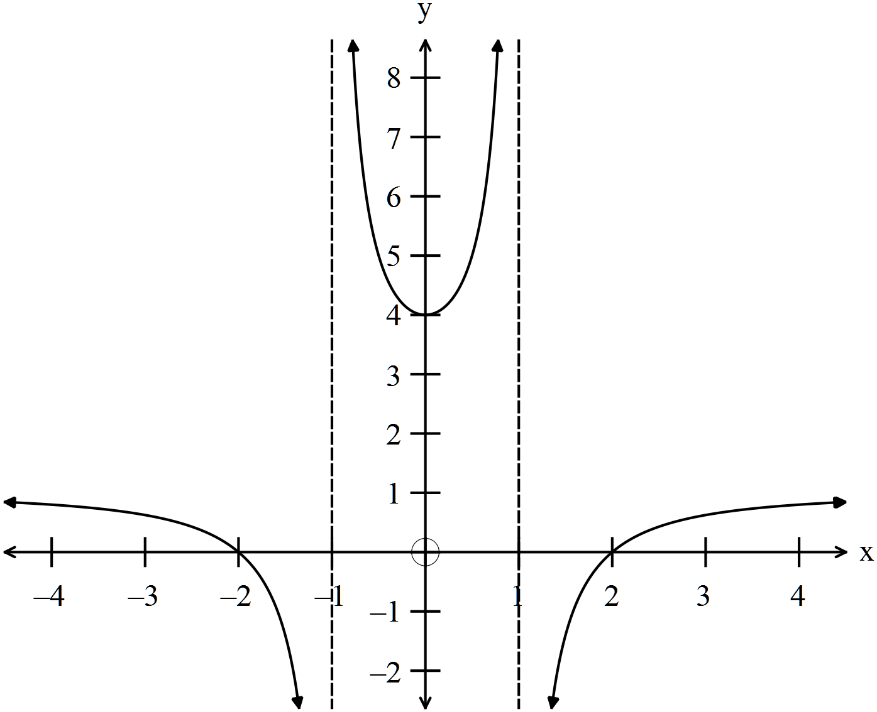

(b)  (3)



4. (8 marks)

The function $f$ is defined as $f\left(x\right)=\frac{x^{2}-1}{x^{2}+1}$.

(a) Show that the **only** stationary point of the function occurs when $x=0$. (2)

(b) Sketch the graph of $y=f(x)$ on the axes below. (3)

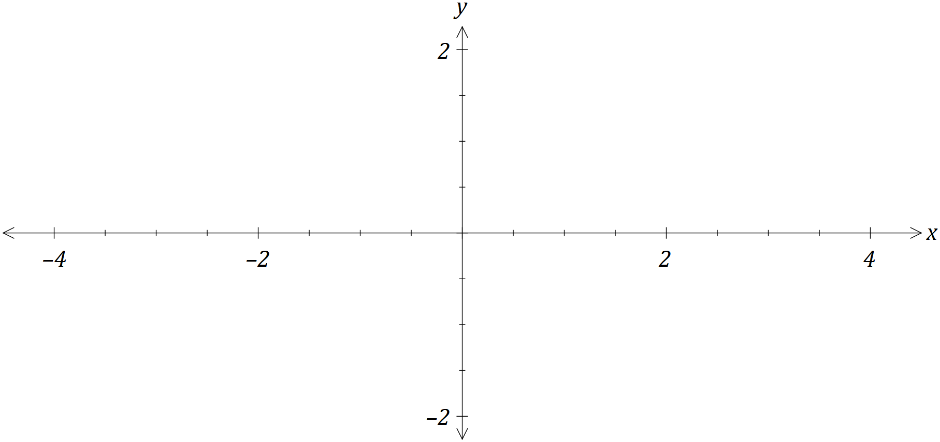

(c) Using your graph, or otherwise, determine all solutions to

(i) $f\left(x\right)=\left|f(x)\right|$. (1)

(ii) $f\left(x\right)=f(\left|x\right|)$. (1)

(iii) $f\left(x\right)=\frac{1}{f\left(x\right)}$. (1)

**MATHEMATICS SPECIALIST 3 & 4** Name_________________

**Test 1 2017**

**Section One: Calculator-assumed**

Reading Time: 3 minutes

Time Allowed: 30 minutes Total Marks: 24

5. (5 marks)

Consider the function .

(a) Explain why it is necessary to restrict the natural domain of f in order that its inverse is also a function. (1)

(b) State a minimal restriction to the domain of f that includes , and then use this restriction to show that . (4)

6. (6 marks)

Consider the functions  and 

(a) (i) Find the expression for and the domain such that

the function is defined. (2)

(ii) Determine whether or not the function  is a one to one

function. Explain. (1)

(b) Find the function  given 

(3)

7. (4 marks)

The graph of  is shown below.

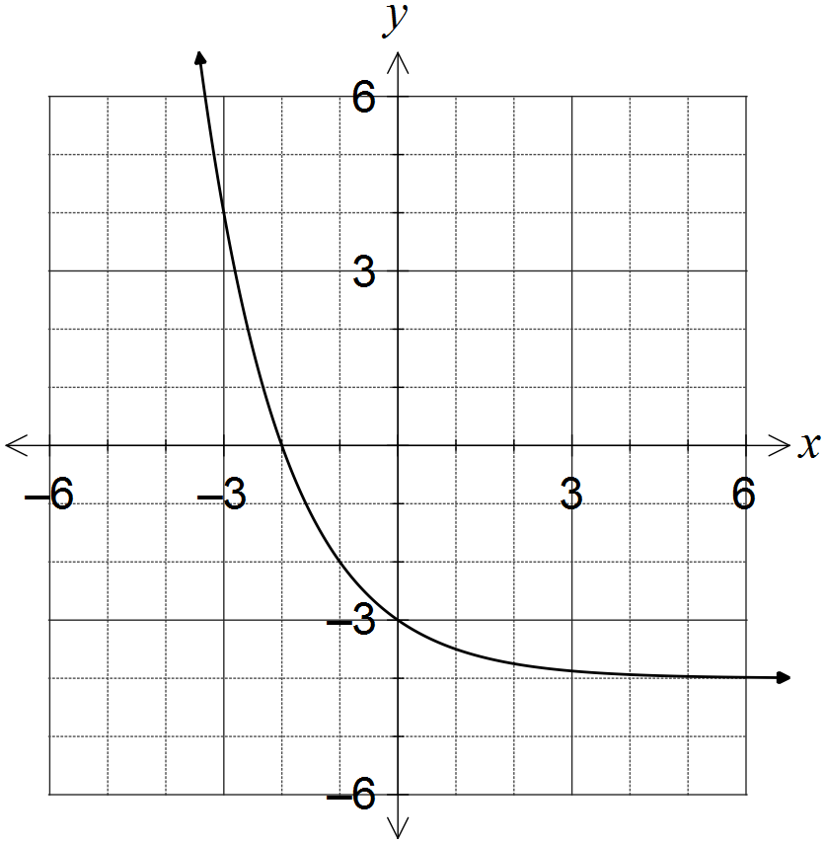

(a) What feature of the graph suggests that the inverse of f is a function? (1)

(b) On the same axes, sketch the graph of the inverse of f, . (3)

8. (5 marks)

Determine the equation of the rational function  whose graph is below.

 and 

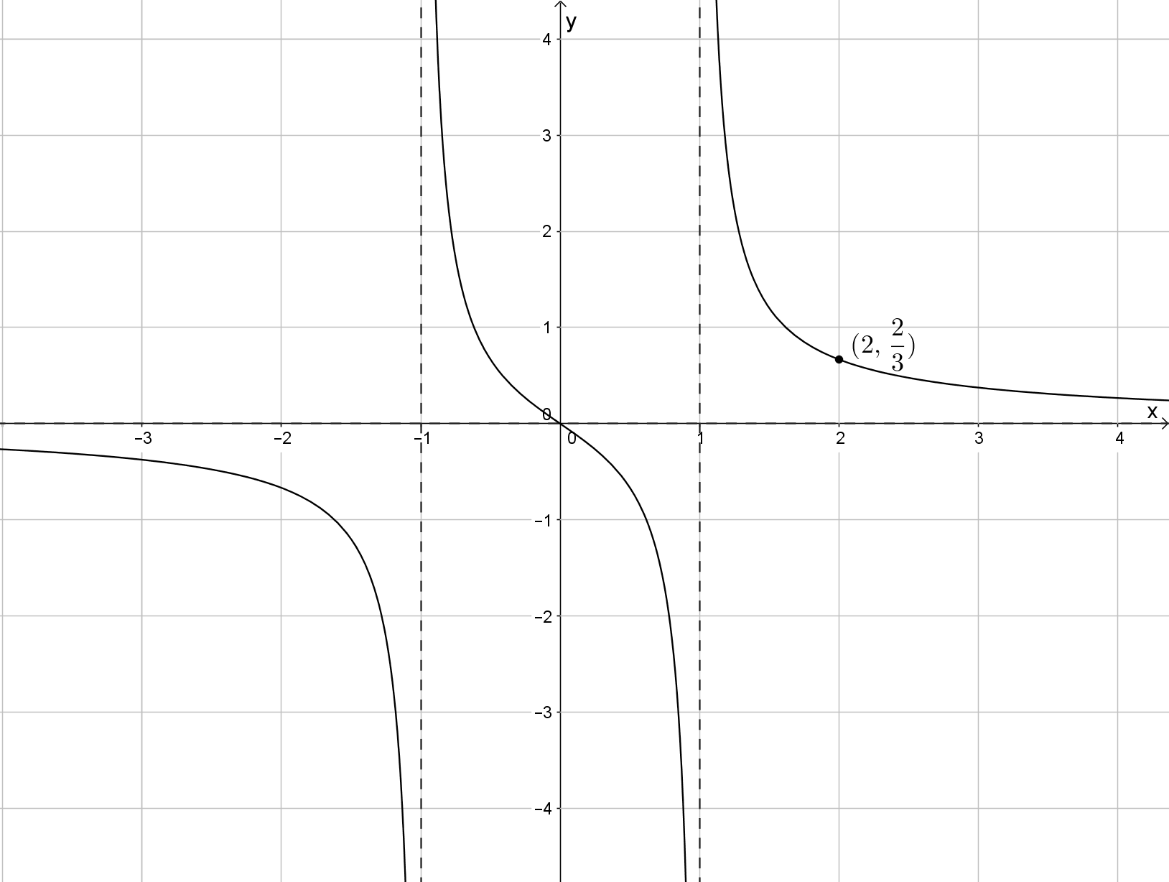

9. (4 marks)

Investigate the number of solutions for the equation .